The goal of this document is to outline a method for converting a Yahboom tank solution for use with LoRa and Jetson Tx2.

<https://category.yahboom.net/collections/r-tank-robot/products/g1tank>

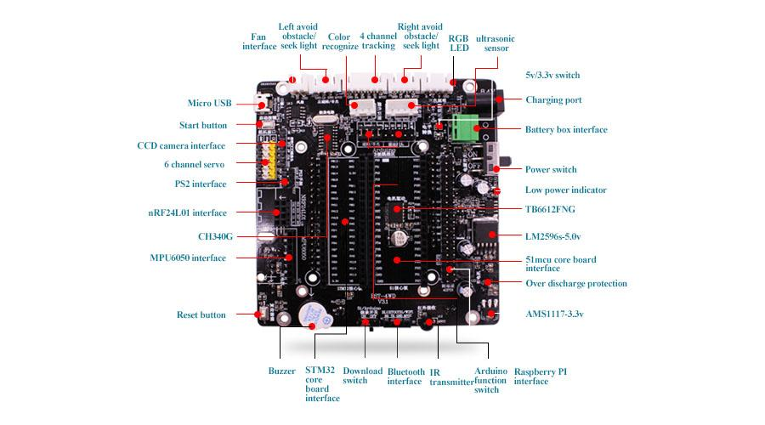

<https://github.com/YahboomTechnology/JetBot-AI-Robot-Car/blob/master/Jetbot%20Hardware%20Manual.pdf>

